**SYS 611-TERM PROJECT**

**Model A Sport LEGO Vehicles Production**

**Advisor**

Prof. Paul Grogan

**Students**

Rushabh Barbhaya, Alkim Avsar

**Date**

December 17, 2018

1. **INTRODUCTION & MOTIVATION**
2. **OBJECTIVES**

In a production company, there are several aspects effecting your sales and profit. Manufacturing part is the one of the most essential parts since the production duration, quality and quantity of the product, labor cost and machine cost variables are all dependent to this part of the company. For a high profitable company, the managers are expecting to have the high efficiency rates from the manufacturing plants. Task divisions in manufacturing processes can lead to a more efficient production cycle. A manufacturing system having members specialized in smaller tasks rather than each person dealing with the larger task; increase its productivity and at the same time decrease the duration of production. Having a team member trained and specialized in just one task, makes that person quicker in that certain task. When you consider in this perception, having decreased production durations in each small task is going to give you a much efficient system level process. Moreover, controlling the workers and each small task would become much easier.

Accordingly, in this report we want to observe the efficiency differences between teams having specialized members in small tasks and teams having each member working on the large-scale task. We are going to use Model A Sport LEGO Vehicles Production in class activity data and create our own model for running simulations for different compositions of teams in order to observe the differences among teams.

1. **SYSTEM DESCRIPTION**

So, what is Model A Sport LEGO Vehicle Production Activity?

The aim of this activity is to observe differences between manufacturing efficiencies in a limited time for mass production. For this purpose, there were three teams in the class activity having the same number of team members. The teams were supposed to buy their chassis and start producing their own cars and sell them to the buyers. They need to pass the quality check in order to be able to sell the cars to buyers. The team having the highest profit in the end of the activity becomes the winner. Accordingly, the main goal is to build as many cars as possible in the limited time range.

The teams are supposed to build their cars from the LEGO parts provided by the designer of the activity. After that, they are free to create their own manufacturing model. There are 13 LEGO parts for being able to build the Model A Sport LEGO Vehicle (Image 1):

1. Chassis (1 per car)
2. Side Section (2 per car)
3. Wheels (4 per car)
4. Wheel Trolley (2 per car)
5. Rear Lights (2 per car)
6. Back Section 1 (1 per car)
7. Back Section 2 (2 per car)
8. Single Seat (1 per car)
9. Steering Wheel (1 per car)
10. Front Section 1 (1 per car)
11. Front Section 2 (2 per car)
12. Front Section 3 (1 per car)
13. Headlights (2 per car)

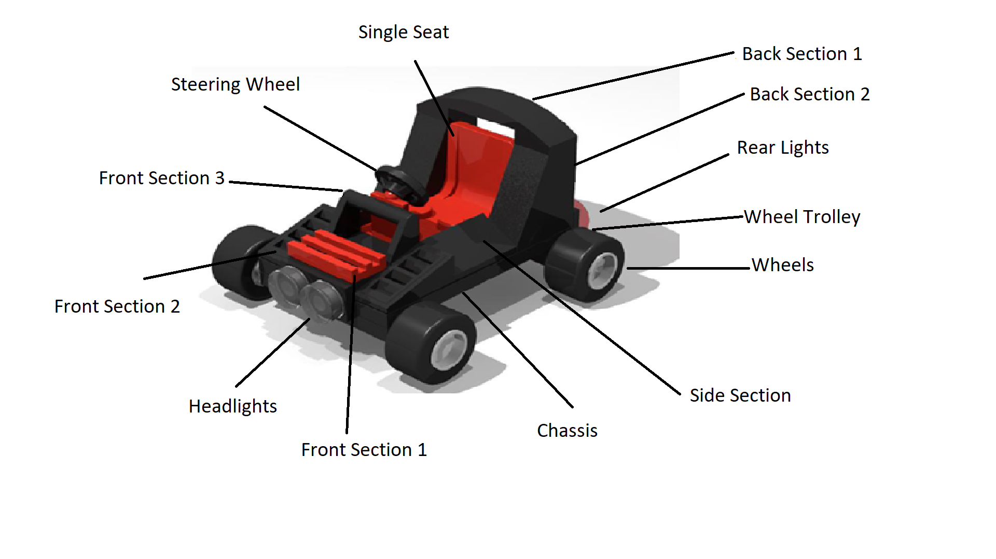

Image 1: Indicates the Model A Sport LEGO Vehicle with all parts

The system boundaries can be summarized in seven factors:

* All teams start with the same amount of money of 100 dollars
* The price for chassis are fixed as 30 dollars
* The price teams earn after the cars are fixed as $105 per car
* All teams need to have same number of members (four or five members)
* All teams have same amount of supplies ready for them before beginning of the activity
* All cars need to be the same as the model car supplied to all teams for being able to put in market
* All cars need to pass the quality check (all parts need to be assembled on the right spot and right place)
* The duration is fixed for all teams as 20 minutes per session

1. **PERFORMANCE MEASURES**

The performance of the teams measured based on the profits they earned after the 1000 seconds of car production. The team, which produced highest numbers of cars, earns the highest revenue. Accordingly, the revenue minus the cost gives us the profit of the team. If the teams bought the chassis for production but could not achieved to sell in the activity duration, they would have a bigger loss. For that reason, the teams should focus on producing as much as they can and at the same time, they should manage their time to finish production for what they bought.

Our aim in this report is to observe how different strategies in the teams are going to affect the outcome (profit) for the teams. For this performance measure, the task distribution among the members tried to be observed. In the class activity, two distinct task distribution choices observed between the teams. Red team followed as strategy as giving specializations to each team member and have a production line among team members. On the other hand, orange team followed a different strategy, each member in that team build one whole car. They did not have a production line, each member worked independent from one another. The class activity outcomes showed that the Red team had a better performance with the higher profit compared to other team. In our performance measurement, we want to observe the effects of specialization in a team based on these results observed.

1. **MODELING APPROACH**
2. **DATA COLLECTION AND PROCESSING**

The data is collected from the in class activity. The data collected via google drive by the suppliers and the buyers. The suppliers collected the information of which chassis sold to which team and at what time. The buyers collected the information of which team sold the car with the chassis IDs and at what time. Accordingly, the system was able to track the chassis from the beginning of the selling process until the end of selling the car with that specific chassis. The data collected in a csv file including the columns of; Chassis ID, team name, starting time (time of buying the chassis from supplier), ending time (time of selling to chassis to buyers), duration (time in between start and end for the same chassis), expense and revenue. The experiment run for two times in order to observing how teams are going to change their strategies by the learning affect in the second round.

While processing the data, the profit of the teams (total revenue – total cost) and total number of cars produced calculated. On the second round, an improvement in all teams observed, especially in the red team. This might be due to the fact that, teams either changed their strategies or become better in the strategy they followed in the first round. Based on this observation, second round data used for further processing and modeling. The team compositions and models decided according to second round activity and data. While processing the data, there were several limitations (which are going to be discussed in the results and discussion section), it is decided that four variables are going to be used for simulation modeling; duration, cost, revenue, team ID. The duration accepted as the random variable. We created random variables for different teams based on the data we already have from the experiment. Rather than following a specific distribution, the collected data from the activity was noisy. That’s why, some specific ranges are decided for creation of random variables for each different team. As the system boundary requirements, the cost and revenue for the cars kept constant (cost = $30, revenue=$105). The outcome, profit, calculated based on revenue – cost relationship and was dependent to randomized duration variable.

1. **MODEL FORMULATION AND DEVELOPMENT**

The first step for model formulation was to decide the different team strategies in order to observe the differences. Accordingly, four different team strategies observed and named as Team A, Team B, Team C, Team D. All these four teams have four members but have different working strategies inside of the teams.

TEAM A:

In Team A, every member of the team is specialized in a different task. They have workflow that each member follows. Member 1 is specialized in assembling the wheel trolleys, wheels on the chassis. Member 2 assemblies the steering wheel, seats and the side section of the car. Member 3 is responsible from the back section, which also includes rear lights. The last member, Member 4, assemblies the front section including the headlights. Chart 1 also indicates the task distributions among Team A’s members.

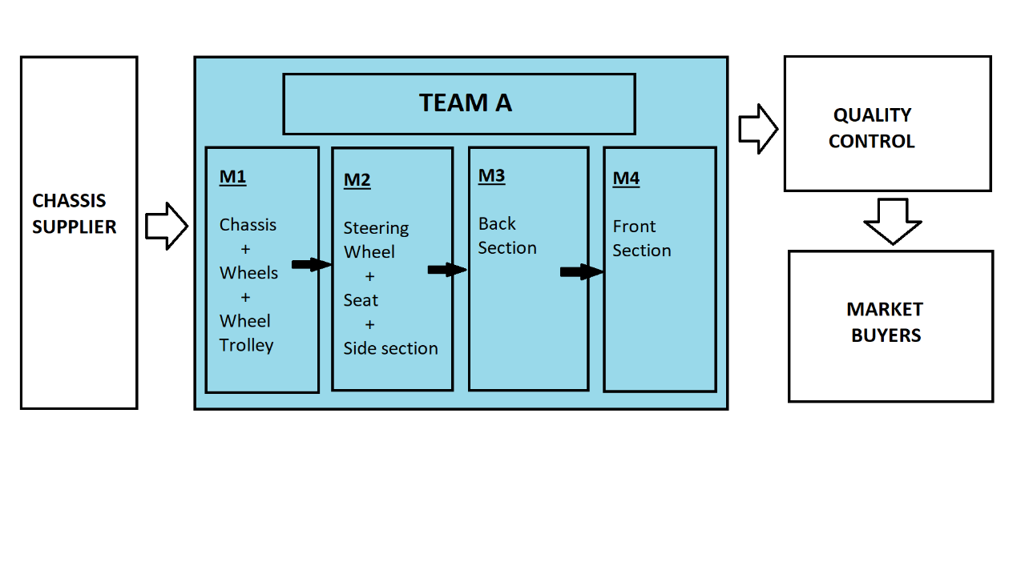

Chart 1: Team A modeling strategy explaining the specializations of each member in the team and their work follow

TEAM B:

Team B has the opposite strategy with the Team A, meaning that, each member in this team are builds one car by assembling every part. There is no workflow in this team due to that reason. Moreover, there is no specialization among the members of Team B. All members need to assemble each one of the parts by themselves. Chart 2 shows the model strategy in this team.

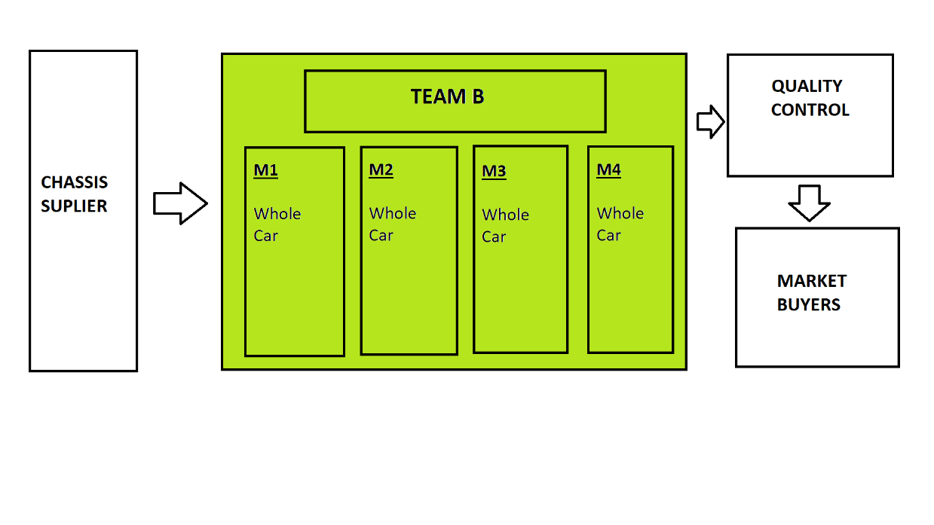

Chart 2: Team B modeling strategy explaining the specializations of each member in the team and their work follow

TEAM C:

Team C has a composite strategy of Team A and Team B. In this model, the team divides by two sub-teams and each sub-team are responsible for the production of a whole car. Sub-teams have two members. Member 1 in Team C-1 and Member 3 in Team C-2 are responsible from the assemblies of wheels, wheel trolleys, side section and front section. Member 2 in Team C-1 and Member 4 in Team C-2 are responsible from the assemblies of steering wheels, seat and back section. The member of the sub-teams are required to have a workflow in between each other. However, there is no total workflow among all members of the teams. Chart 3 shows the modeling of this team.

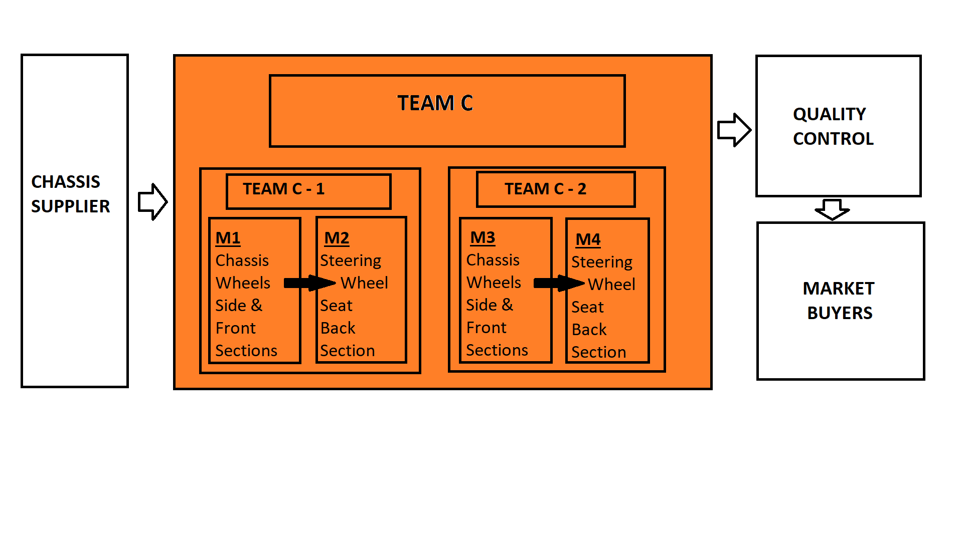

Chart 3: Team C modeling strategy explaining the specializations of each member in the team and their work follow

TEAM D:

Team D has the same strategy and workflow as the Team A. The only difference is, this team has the quality control inside of the team. The team still have to go to quality check but it makes sure that no car will return to the manufacturing side due to a miss-assembly or another deficiency in the car. In this model, we wanted to observe how failing from the quality control affects the company and is a good idea to do a previous quality check inside of the company or is it unnecessary due to loss of extra time. The workflow in for this team is shown in chart 4.

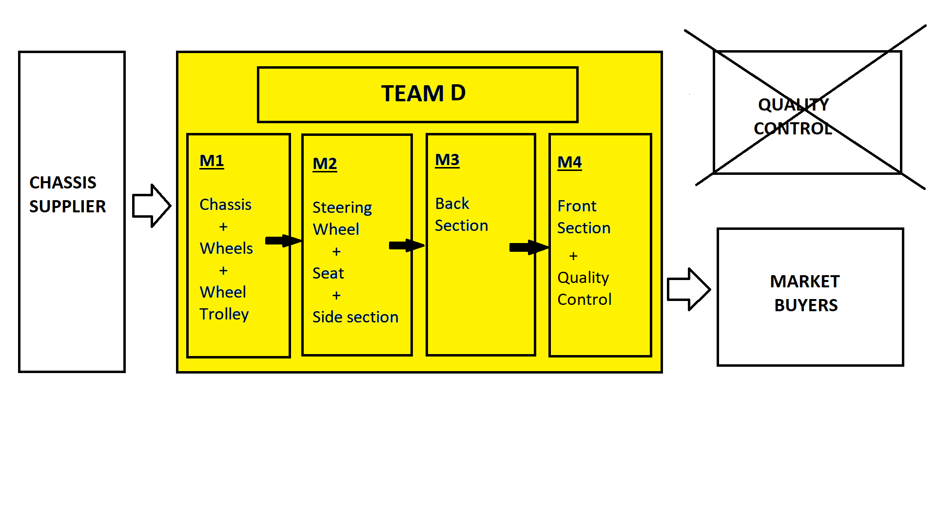

Chart 4: Team C modeling strategy explaining the specializations of each member in the team and their work follow

These four models created in the python environment. A Monte Carlo simulation run for observing the differences among the team models. Monte Carlo simulation decided to be used since our aim was to simulate the probability in order to understand the probable outcomes and confidence intervals. For having simulating this, random variables created within a range for the duration of producing one car. The range of duration decided via estimating the maximum and minimum time limits for the production for each different team strategy. For instance, for Team A, a total duration for whole team production line estimated while for Team B a duration for individual member durations estimated since each member was independent from each other in Team B. For these estimations, we tried to use the worst and best cases from the collected data. From this simulation, our expectation was being able to observe more realistic scenarios of what might happen if the same activity had been done several times (100 times for example or even more). In the in-class activity, the total time range was 20 minutes (1200 seconds), in order to have close approximate results, we limited our simulations in a limited time range of 1000 seconds. After simulating these for models, we are expecting to observe possible/various results of each different model.

1. **MODEL VALIDATION**

The models we have created are formed based on the observed in-class activity and its results. Accordingly, we just tried to fit our estimations in a valid range of values. Other numbers were already fixed from the in-class activity. We just changed the revenue from $104 to $105 for having more round up values. Also, we decreased the time range from 1200 to 1000 since we estimated smaller values for the duration. This was due to the fact that, in the collected data, the duration for production of a car was also including the buying and selling process. In our own analysis, we just wanted to observe the car manufacturing process. For that reason, we estimated as 200 seconds of production process in the class activity went for the selling and buying process and we decreased our total duration. Moreover, we used much smaller time durations for car production of teams. However, all these estimates calculated based on ratios from the observed data. The models are fitted and validated based on Orange Team and Red Team. These two teams gave us the basis information for creating our own models are for our estimations.

1. **RESULTS & ANALYSIS**
2. **STUDY DESIGN AND CONDITIONS**

The same parameters and boundaries set as stated in the system description section. There have been few adjustments for being able to have better observations and results. The four alternative models created and run as described model description and development section. The boundaries and parameters for the simulation are:

* The price for chassis are fixed as 30 dollars
* The price teams earn after the cars are fixed as 105 dollars per car
* All teams have 4 members
* All teams have same amount of supplies ready for them before beginning of the activity
* All cars need to be the same as the model car supplied to all teams for being able to put in market
* All cars need to pass the quality check (all parts need to be assembled on the right spot and right place)
* The total production duration is fixed for all teams as 1000 seconds

1. **RESULTS**

Found statistics for Team A:

|  |  |  |  |
| --- | --- | --- | --- |
| Mean | Standard Error | CI-2.5 | CI-97.5 |
| $5943 | 6.8 | $5929.6 | $5956.4 |

Team A has a average of $5943 profit in all 100 trials, the confidence intervals are found as $5929 and $5956.

Found statistics for Team B:

|  |  |  |  |
| --- | --- | --- | --- |
| Mean | Standard Error | CI-2.5 | CI-97.5 |
| $4498 | 9.2 | $4480 | $4516 |

Team B has a average of $4498 profit in all 100 trials, the confidence intervals are found as $4480 and $4516.

Found statistics for Team C:

|  |  |  |  |
| --- | --- | --- | --- |
| Mean | Standard Error | CI-2.5 | CI-97.5 |
| $2906 | 5.75 | $2895 | $2917.7 |

Team C has a average of $2906 profit in all 100 trials, the confidence intervals are found as $2895 and $2917.

Found statistics for Team D:

|  |  |  |  |
| --- | --- | --- | --- |
| Mean | Standard Error | CI-2.5 | CI-97.5 |
| $5644.8 | 7.01 | $5631 | $5658 |

Team D has a average of $5644 profit in all 100 trials, the confidence intervals are found as $5631 and $5658.

**OVERVIEW STATISTICS FOR ALL TEAMS:**



Figure 5: Indicates the Monte Carlo simulation results for 100 trials, shows profit lines for each team

1. **DISCUSSION & CONCLUSION**

The results are showing that Team A would be the winner over several trials with the highest profit mean of $5943 and by producing 56 cars on average. This also shows Team A followed the best strategy for having a high profit. In the in-class activity, the team which earned the highest profit was the Red Team with 2442 dollars. As it can be observed, the collected data results are simulation results are different. However, this is because of the limitations and assumptions during the modeling and analysis part. First of all, in the collected data, there was not a variable as the duration just for car manufacturing process. For that reason, we tried to predict the duration ranges by extracting the selling and buying process estimations from the total duration. This might caused some indifference. Moreover, we created our team models based on the observations during the activity. However, that does not mean that the strategies shows 100% similarity. In our simulation, our aim was to create different models and select the best one for future purposes, for increasing the mass production efficiencies.

Although, because of the limitations and assumptions there are differences in numbers, the results we obtained are parallel with the in-class activity. During the activity, there were three teams in total and two of them followed very different strategies. Team Red preferred to have a workflow and specialized members for each different task. On the other hand, Team Orange preferred each member to work independent from each other build one whole car by each member. In the end of 20 minutes, Team Red earned $2442 profit and Team Orange earned $1982. Based on these results, we were expecting to observe that a team having specialized members for each task should be having better outcomes. As same as the class activity, in our simulation, Team A earned $1445 more on average compared with Team B. This means that, we have enough evidence to support that, a team having specialized members for each task would be more efficient, build more cars and earn more profit in the end.

In our simulation models, there were two more team strategies. In Team C, we halved the team and each two member have a workflow among them to create one car. The results of the simulations, showed that was the worst strategy for a team since Team C have only 2906 dollars of profit on average. In Team D we wanted to observe if we can gain time from the quality control by minimizing the returned car numbers to manufacturing site. Accordingly, we followed the same strategy and workflow as Team A and just added quality control and extracted returned car numbers back to teams. This strategy selected as the second best after Team A. However, the results suggested that, adding a quality control inside of the team workflow is not beneficial, it causes loss of time and money more than it brings gains.

Accordingly, from our simulations, we suggest, production companies/teams need to have a task distribution among members for increasing their overall profit. Having specialized members in each task would help teams to gain money and time in the mass production sites.

For future works, refinements on Team A can be done. The strategy of Team A can increased further by changing some dynamics inside. For instance, for Team A we calculated the overall duration for production of a car, in future works the duration for each task/member can be estimated and specialization contents may change accordingly. This can give us further information about how the production line should change and which way is the most efficient.

1. **REFERENCES**
2. <https://smallbusiness.chron.com/specialization-labor-can-lead-increased-productivity-12347.html>
3. <http://www.npd-solutions.com/pdt.html>
4. <https://www.google.com/url?sa=t&rct=j&q=&esrc=s&source=web&cd=3&cad=rja&uact=8&ved=2ahUKEwjp45fv3qTfAhUNmbQKHfTwAv0QFjACegQIBxAK&url=https%3A%2F%2Fwww.riskamp.com%2Ffiles%2FRiskAMP%2520-%2520Monte%2520Carlo%2520Simulation.pdf&usg=AOvVaw3mqfDwNO5-Q7TqDlT1sJOn>